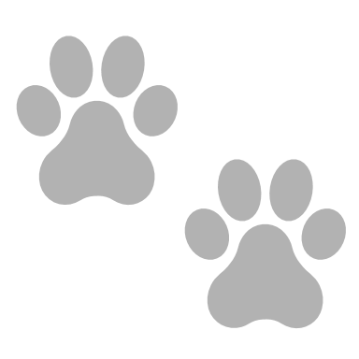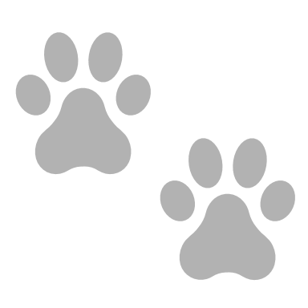

I promise to love and take good care of my teddy.

I will always remember how special my knitted teddy

is to me and I will give it lots of cuddles.

………………………..……………..…….… ………….……………………..

(signature) (date)

**CERTIFICATE**

of adoption

*This certifies that* …………………………………………………….…….……..…

*has officially adopted* …………………………………….……………………

*knitted with love by* ………………………..…………………………….