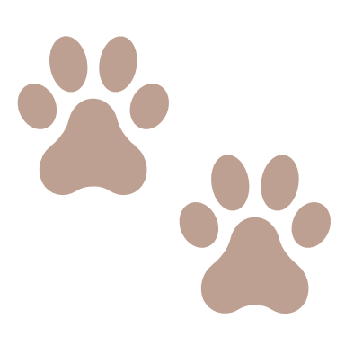

(signature) (date)

I promise to love and take good care of my teddy.

I will always remember how special my knitted teddy

is to me and I will give it lots of cuddles.

………………………..……………..…….… ………….……………………..

*This certifies that* ………………………………………………….….…….……..…

*has officially adopted* …………………………………….……………………

*knitted with love by* ………………………..…………………………….

**CERTIFICATE**

of adoption